Cognos Training – Level II
Basic Report Writing in Financial Data Mart (FDM) - Crosstab Reports 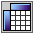

Crosstab reports summarize data in a table, much like a pivot table in Excel. The report has rows and columns, but the intersections of the rows and columns represent summary data.

Cognos-DEV – https://cognos-dev.udel.edu/cognos8
Cognos (production) - https://cognos.udel.edu/cognos8

- Login with your UDelNet ID and password
- Under My Actions, choose Create professional reports (Report Studio)

Navigate to the yellow content folder FDM packages, click on name

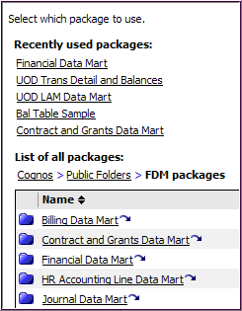
Two ways to open Financial Date Mart:

- Recently used packages
- List of all packages

This will launch Report Studio

Click on Create a new report or template

- Double-click on the Crosstab icon

- There are three areas in a Crosstab report:

- Columns – data elements along the top
- Rows – data elements along the side
- Measures – the data (numbers) that get summarized

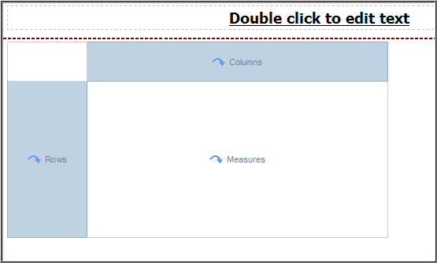

A. Create Crosstab Report

- Create a crosstab report using transaction data
  - In Insertable Objects, open UD Financial Data Mart and Financial Data Mart

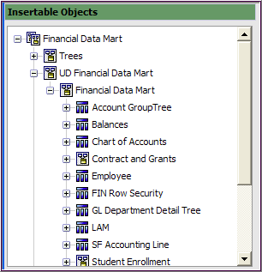
  - These 4 fields will be added to Rows in the Work Area:

Field Name | Query Subject | Folder
PURPOSE | Chart of Accounts | Purpose
PURPOSE_DESCR | Chart of Accounts | Purpose
FISCAL_YEAR | Trans Detail | Dates
ACCOUNTING_PERIOD | Trans Detail | Dates

    - Drag & drop PURPOSE to Rows in the work area

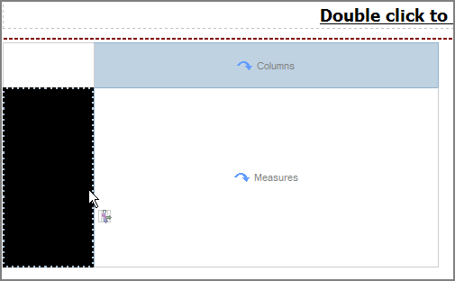
Note – Double-clicking for adding fields does not work with Crosstabs

    - Drag & drop PURPOSE_DESCR next to PURPOSE (thin blinking line)

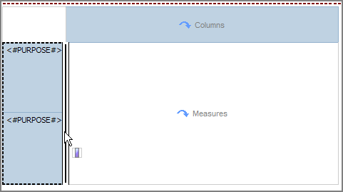

    - The work area should look like below
    - Drag and drop FISCAL_YEAR next to PURPOSE_DESCR (thin blinking line)

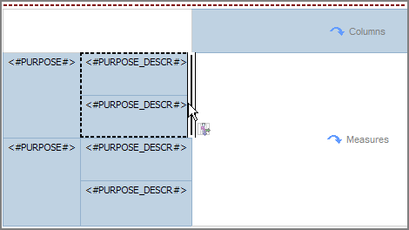
    - The work area should look like below
    - Drag & drop ACCOUNTING_PERIOD next to FISCAL_YEAR (thin blinking line)

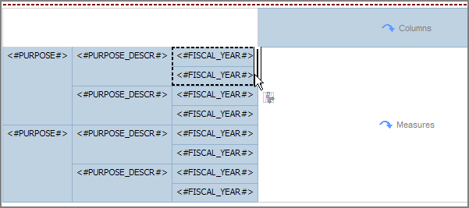

    - The Rows in the work area should look like this:

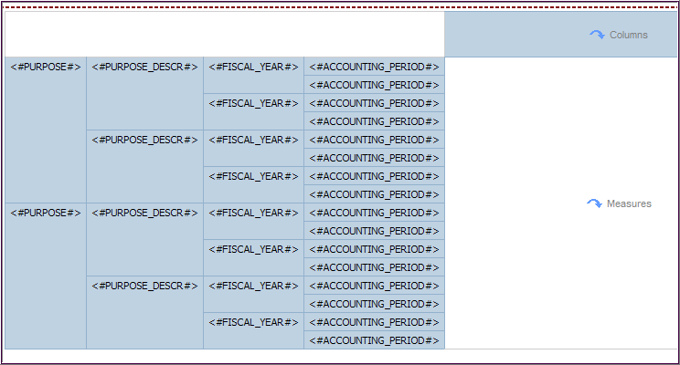

  - Add these 2 fields in Columns:

Field Name | Query Subject | Folder
ACCOUNT | Chart of Accounts | Account
ACCOUNT_DESCR | Chart of Accounts | Account

    - Drag & drop ACCOUNT to Columns in the work area

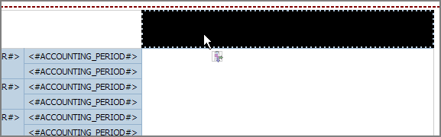

    - Drag and drop ACCOUNT_DESCR under ACCOUNT (thin, blinking line)

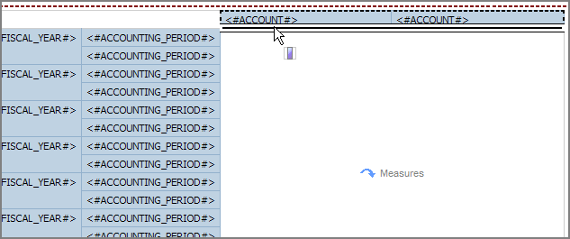

    - The Columns in the work area should look like this:

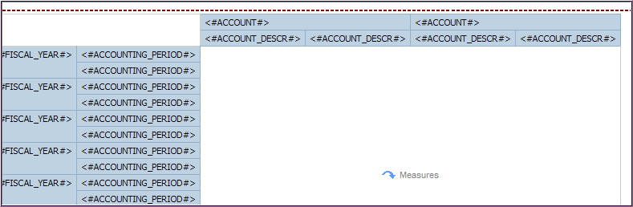

  - Add this field to the Measures:

Field Name | Query Subject | Folder
TRANS_AMOUNT | Trans Detail

    - Drag & drop TRANS_AMOUNT to Measures in the work area

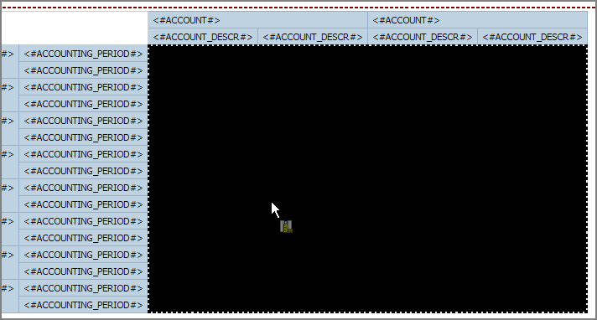
    - The work area should look like this:

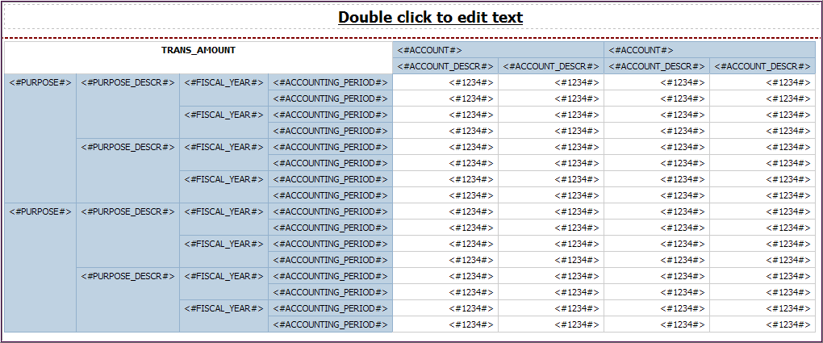

- Click Save and choose My Folders, name it BASIC Crosstab

- In the toolbar, use Sort to sort following fields Ascending:
  - Purpose
  - Account
  - Fiscal Year
  - Accounting Period

- Your work area should look like this (partial view):

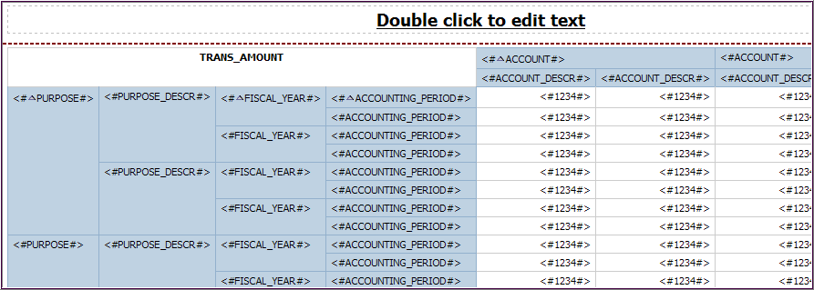

- Add two pre-written Prompts to your report from the Prompts folder:
(Scroll to the bottom of Insertable Objects)
- Purpose Prompt
- Between year and period Prompt

- Add three pre-written Filters to your report from the Filters folder:
(Scroll to the bottom of Insertable Objects)
- ACTUALS Ledger Filter
- Journal ID not blank Filter
- Statistics Code not ENP ENU Filter
- Save your work

- Make Transaction Amount two decimal places
  - Click measures of the report where you see <#1234#> repeated
  - Go to the Properties pane (lower left)
  - In the Data section, click Data Format
  - Click the Ellipses to open the Data Format window
  - In Format type dropdown, select Number
  - In Properties, click No. of Decimal Places
  - Using dropdown, select 2
  - Click OK

- Save your work

- Run the report with multiple Purpose codes

- Switch the fields that are columns and rows
  - Click anywhere on the report in the work area
  - In the toolbar, click the Swap Columns and Rows button

  - The work area will look like this (partial view):

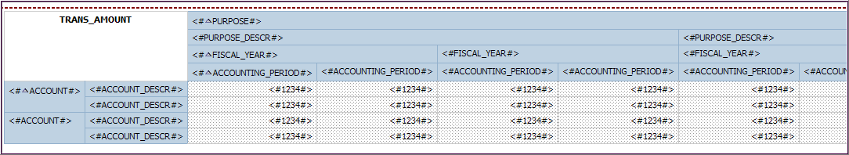

  - Run the report with mutiple Purpose codes

- Add totals to your report:
  - Click measures of the report where you see <#1234#> repeated
  - In the toolbar, cick the Aggregate button and choose Total

  - The work area will look like this:

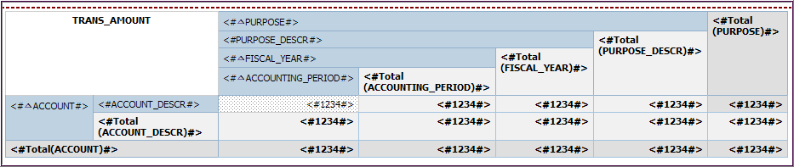

  - Run the report with mutiple Purpose codes
- Notice there are a proliferation of new columns and rows with totals that are not useful

  - Delete the following 2 columns and 1 row with totals:
    - Click the box with the <#Total (FIELD)#> to highlight it and click

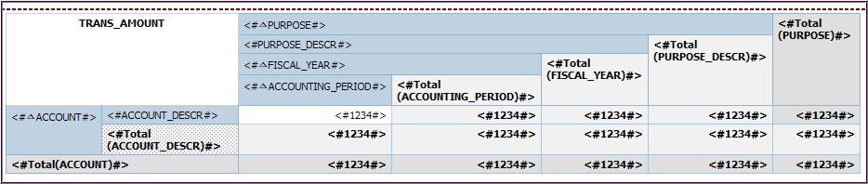
[delete]
[delete]
[delete]

  - Run the report with mutiple Purpose codes

- Change the names of the total columns and total row
  - Click the row title that says <#Total(ACCOUNT)#>
    - In the Properties pane, go to Data Item/Name
    - Delete <#Total(ACCOUNT)#> and type: Total by Period

  - Click the column title <#Total(ACCOUNTING_PERIOD)#>
    - In the Properties pane, go to Data Item/Name
    - Delete <#Total(ACCOUNTING_PERIOD )#> and type: Total by Account and Periods

  - Click the column title <#Total(PURPOSE)#>
    - In the Properties pane, go to Data Item/Name
    - Delete <#Total(PURPOSE#> and type: Total by Account and Purposes

  - Run the report with multiple Purpose codes

  - Save your work

B. Modify an Existing List and Convert it to a Crosstab

- Open an existing list report: BASIC List - Trans Detail
- Immediately save it with a new name (File/Save As) – List to Crosstab
- Cut these 17 un-needed fields by click their column titles:
  - TRANS-DESCRIPTION
  - TRANS_SOURCE
  - JOURNAL_ID
  - VNDR_NAME1
  - VOUCHER_ID1
  - JRNL_LN_REF

Cut vs. Delete

Cut removes the data item from the report layout but retains it in the query that Cognos uses to retrieve data from the source. To add it back, go to the Data Items tab.

Delete removes the data item from the report layout and the query.

  - ACCOUNTING_DT
  - TRANSACTION_DATE
  - DEPTID
  - ACCOUNT_TYPE
  - CLASS_FLD
  - FUND_CODE
  - PROGRAM_CODE
  - CHARTFIELD2
  - CHARTFIELD3
  - PROJECT_ID
  - LEDGER

(Note – This will leave 7 fields: PURPOSE, PURPOSE_DESCR, FISCAL_YEAR, ACCOUNTING_PERIOD, ACCOUNT, ACCOUNT_DESCR and TRANS_AMOUNT.)

- Choose the fields you want to become the columns in your crosstab
  - Shift-click these four column titles to select multiple adjacent fields:
      - PURPOSE
      - PURPOSE_DESCR
      - FISCAL_YEAR
      - ACCOUNTING_PERIOD

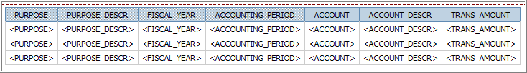

- Click Pivot List to Crosstab

- Your work area should look like this (partial view):

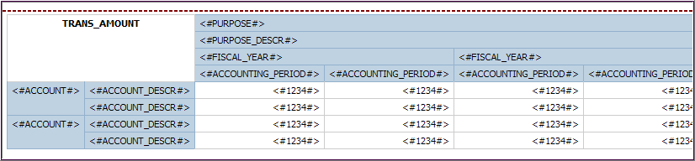

- Save your work

- Run the report
C. Create a Drill Through report

You will be creating two reports:
- A target report with detailed data (child) – this will be a List
- A source report with high level data (parent) – this will be a Crosstab
- ACCOUNT will be the field you drill down through

- Target report - create a New List report and add these 16 fields:

Field Name | Query Subject | Folder
PURPOSE | Chart of Accounts | Purpose
PURPOSE DESCR | Chart of Accounts | Purpose
FISCAL_YEAR | Trans Detail | Dates
ACCOUNTING_PERIOD | Trans Detail | Dates
ACCOUNT | Chart of Accounts | Account
ACCOUNT_DESCR | Chart of Accounts | Account
CLASS_FLD | Chart of Accounts | Class
CHARTFIELD_3 | Chart of Accounts | Chartfield3
ACCOUNTING_DT | Trans Detail
TRANSACTION_DATE | Trans Detail
JOURNAL_ID | Trans Detail
TRANS_SOURCE | Trans Detail
JRNL_LN_REF | Trans Detail
TRANS_DESCRIPTION | Trans Detail
VNDR_NAME1 | Trans Detail
TRANS_AMOUNT | Trans Detail

- Add 2 pre-written Prompts to your report by double-clicking them:
(Scroll to the bottom of the Insertable Objects)
  - Purpose
  - Between year and period

- Add three pre-written Filters to your report by double-clicking them:
(Scroll to the bottom of Insertable Objects)
  - ACTUALS Ledger Filter
  - Journal ID not blank Filter
  - Statistics Code not ENP ENU Filter

- From the toolbar, add a Filter to enable the drill-through for ACCOUNT
  - Click Add
  - In Available Components, click Data Items tab
  - Double-click ACCOUNT to add it to the expression
  - Type: =?ACCOUNT?
  - The expression should look like this

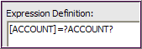

  - Validate it and click OK twice
(Note – it doesn’t matter which Account you choose in the prompt page.)

- Save the report in My Folders and name it Target Details - List

- Source report – Open existing report Basic Crosstab

- Immediately save it in My Folders with new name Source – Crosstab

- Click on Account row where it looks like: <#ACCOUNT#>

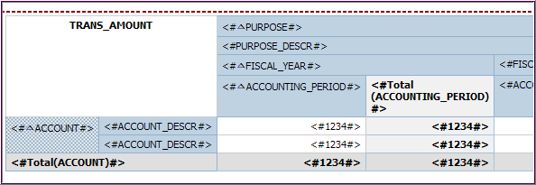

- Click Drill-Through Definitions

- When the Drill-Through Definitions window appears, click New

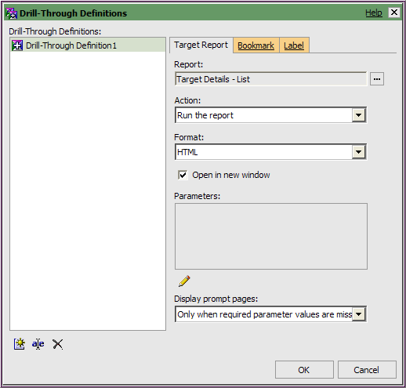

- Report, click the Ellipses and double-click Target Details – List

- Action, choose Run the report

- Format, choose HTML

- Click the checkbox for Open in new window

- In Display prompt pages, leave unchanged (Only when required parameter values are missing)

- Click Edit

- Configure the Parameters to match the Methods and Values shown below:

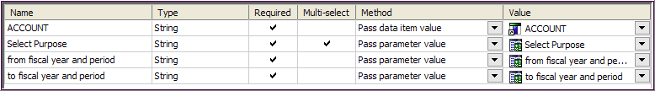
HINT – Parameters settings - Method

Pass parameter value will pass the value based on the prompt value.

Pass data item value will pass the value based on data in your source report. This is your drill-through data elelment.

- Click OK twice

- Save your work

- The ACCOUNT row title displays as a link to show the drill-through:

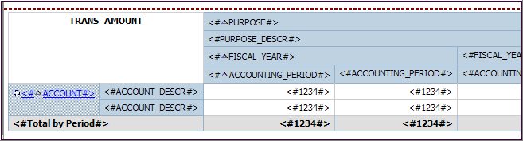

- Run the report

- Click one of the Account links to see the drill-through in action

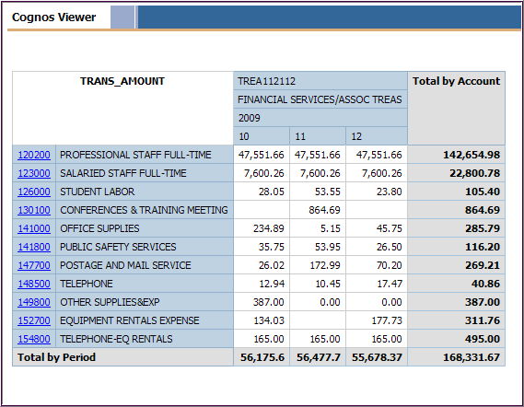

PURPOSE TITLE
XXXX110000

